Dairy manure as a fertilizer source
EM 8586
Reprinted August 1997
J. Hart, M. Gangwer, M. Graham, and E.S. Marx
Most dairies need no commercial fertilizer if they use manure properly. In most cases, manure can supply all the nitrogen, phosphorus, potassium, and several other nutrients needed for forage production.
More than half the nutrients in dairy rations are excreted in manure. The key to managing manure is to treat it as a resource by recycling these nutrients to produce forage. For example, one lactating dairy cow's manure can supply enough nitrogen for 1.5 acres of silage corn.
This publication examines several aspects of the nutrient content and value of dairy manure:
- Nutrient flow through a dairy
- Distribution of nutrients in manure
- Dairy manure nutrient content
- Value of manure

Nutrient flow through a dairy
Nutrients enter your farm in feed and fertilizer. Cows remove nutrients from feed for metabolism and milk production.
Some nutrients leave the farm in milk, but most are excreted in manure and remain on the farm. Manure applications return nutrients to the soil, where they can be reused to produce more feed.
Figure 1 illustrates nutrient flow through a dairy.
Figure 2 shows a cow's daily feed intake and where the nutrients end up. Note that more than half the nutrients in feed are excreted in manure.
Each year, a 1,400-pound lactating cow producing 70 pounds of milk per day excretes the following nutrients in manure:
- 300 pounds of nitrogen
- 45 pounds of phosphorus
- 165 pounds of potassium
Contrast these amounts to the smaller quantities of nutrients that leave the farm each year in milk:
- 100 pounds of nitrogen
- 20 pounds of phosphorus
- 30 pounds of potassium
Only 15 to 25 percent of the nutrients in feed end up in milk. The majority remain in manure, a valuable fertilizer resource for forage production. Figure 3 illustrates the proportions of nitrogen, phosphorus, and potassium excreted in manure and leaving the farm in milk.
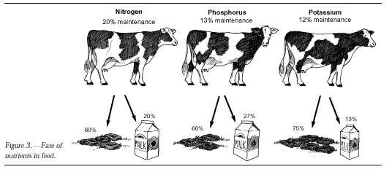

Distribution of nutrients
Not all nutrients are divided evenly between the feces and urine. Most of the phosphorus is found in the feces, while most of the potassium is excreted in the urine. Nitrogen is evenly divided between feces and urine. Figure 4 shows how the nutrient output is divided.
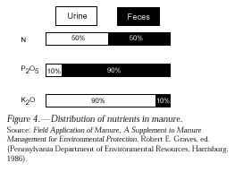

Dairy manure nutrient content
The approximate nutrient composition of manure in four common handling systems is shown in Table 1. Use Table 1 to estimate nutrient amounts remaining for crop use.
For example, 1 acre-inch of typical storage pond effluent provides more than twice the nitrogen needed for one cutting of grass forage or more than half the nitrogen needed for a corn silage crop.
Nutrient amounts are expressed in the same way as a fertilizer analysis:
- Total nitrogen (N)
- Phosphorus (P) as P2O5
- Potassium (K) as K2O
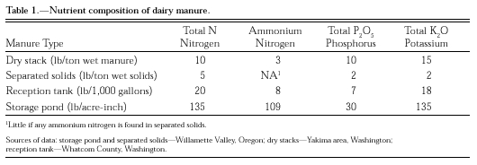
The second column in Table 1 indicates the amount of ammonium N (NH4-N). Ammonium N is readily available to plants. Most of the nitrogen found in storage ponds is in the form of ammonium nitrogen, and therefore is available to crops.
In contrast, nitrogen in other forms is only slowly available to plants. This is why only half the nitrogen from separated solids is available to plants during the growing season.
Potassium from any of the sources is readily available to plants. Most of the phosphorus is available the season manure is applied.
Sample and analyze manure from your dairy.
Nutrient content varies widely from farm to farm. For example, Table 2 shows the low, average, and high nitrogen content of solids from 51 Willamette Valley separators. Nitrogen content varies almost sixfold from the low to high analysis.
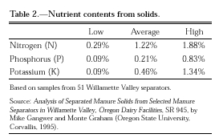

Value of manure
Nitrogen generally is the limiting nutrient to plant growth and the most expensive to purchase. Nitrogen in commercial fertilizer costs approximately 30 cents per pound and $5 per acre to apply. Phosphorus costs 20 cents per pound, and potassium costs 15 cents per pound.
Figure 5 shows the annual fertilizer value of manure from 100 dairy cows. This illustration does not take into account loss during storage or handling or incomplete availability of nutrients.
If losses and incomplete availability are taken into account, the annual value of nutrients in manure from 100 lactating cows exceeds $10,000.
Proper management of manure can increase farm profits and reduce risk of environmental damage.
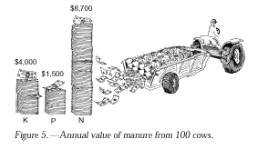

Prepared by John Hart, Extension soil scientist, Oregon State University; Mike Gangwer, Extension agent, Marion County, Oregon State University; Monte E. Graham, soil conservationist, USDA Natural Resource Conservation Service; and E.S. Marx, former research assistant in soil science, Oregon State University.
Reprinted August 1997.

Produced and distributed in furtherance of the Acts of Congress of May 8 and June 30, 1914. Extension work is a cooperative program of Oregon State University, the U.S. Department of Agriculture, and Oregon counties. Oregon State University Extension Service offers educational programs, activities, and materials without discrimination based on age, color, disability, gender identity or expression, marital status, national origin, race, religion, sex, sexual orientation, or veteran's status. Oregon State University Extension Service is an Equal Opportunity Employer.
Copyright © 1995- 2008 Oregon State University. Disclaimer.

